# Swift与Cocoa框架开发

## 开发一个简单的swift应用

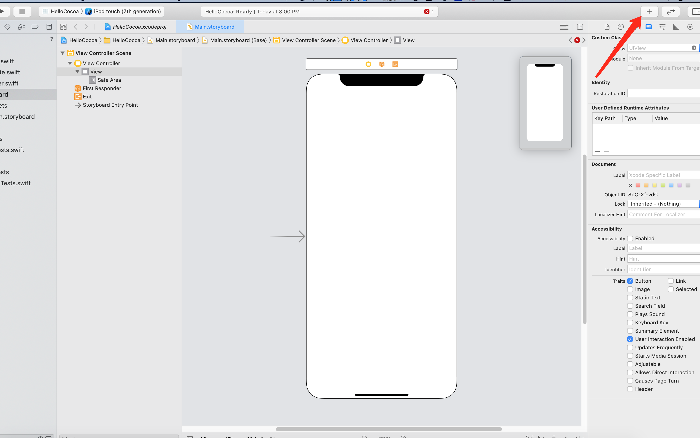

添加控件

<https://developer.apple.com/forums/thread/123079>

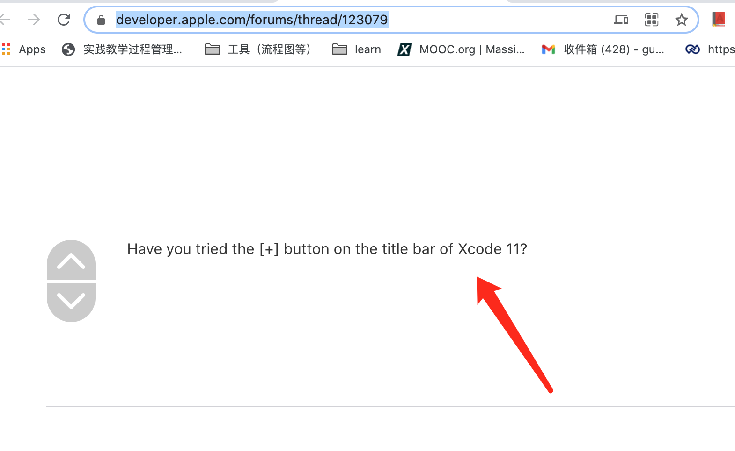

### 显示 assistant editor

<https://stackoverflow.com/questions/56675698/show-assistant-editor-missing-in-xcode-11/56676238>

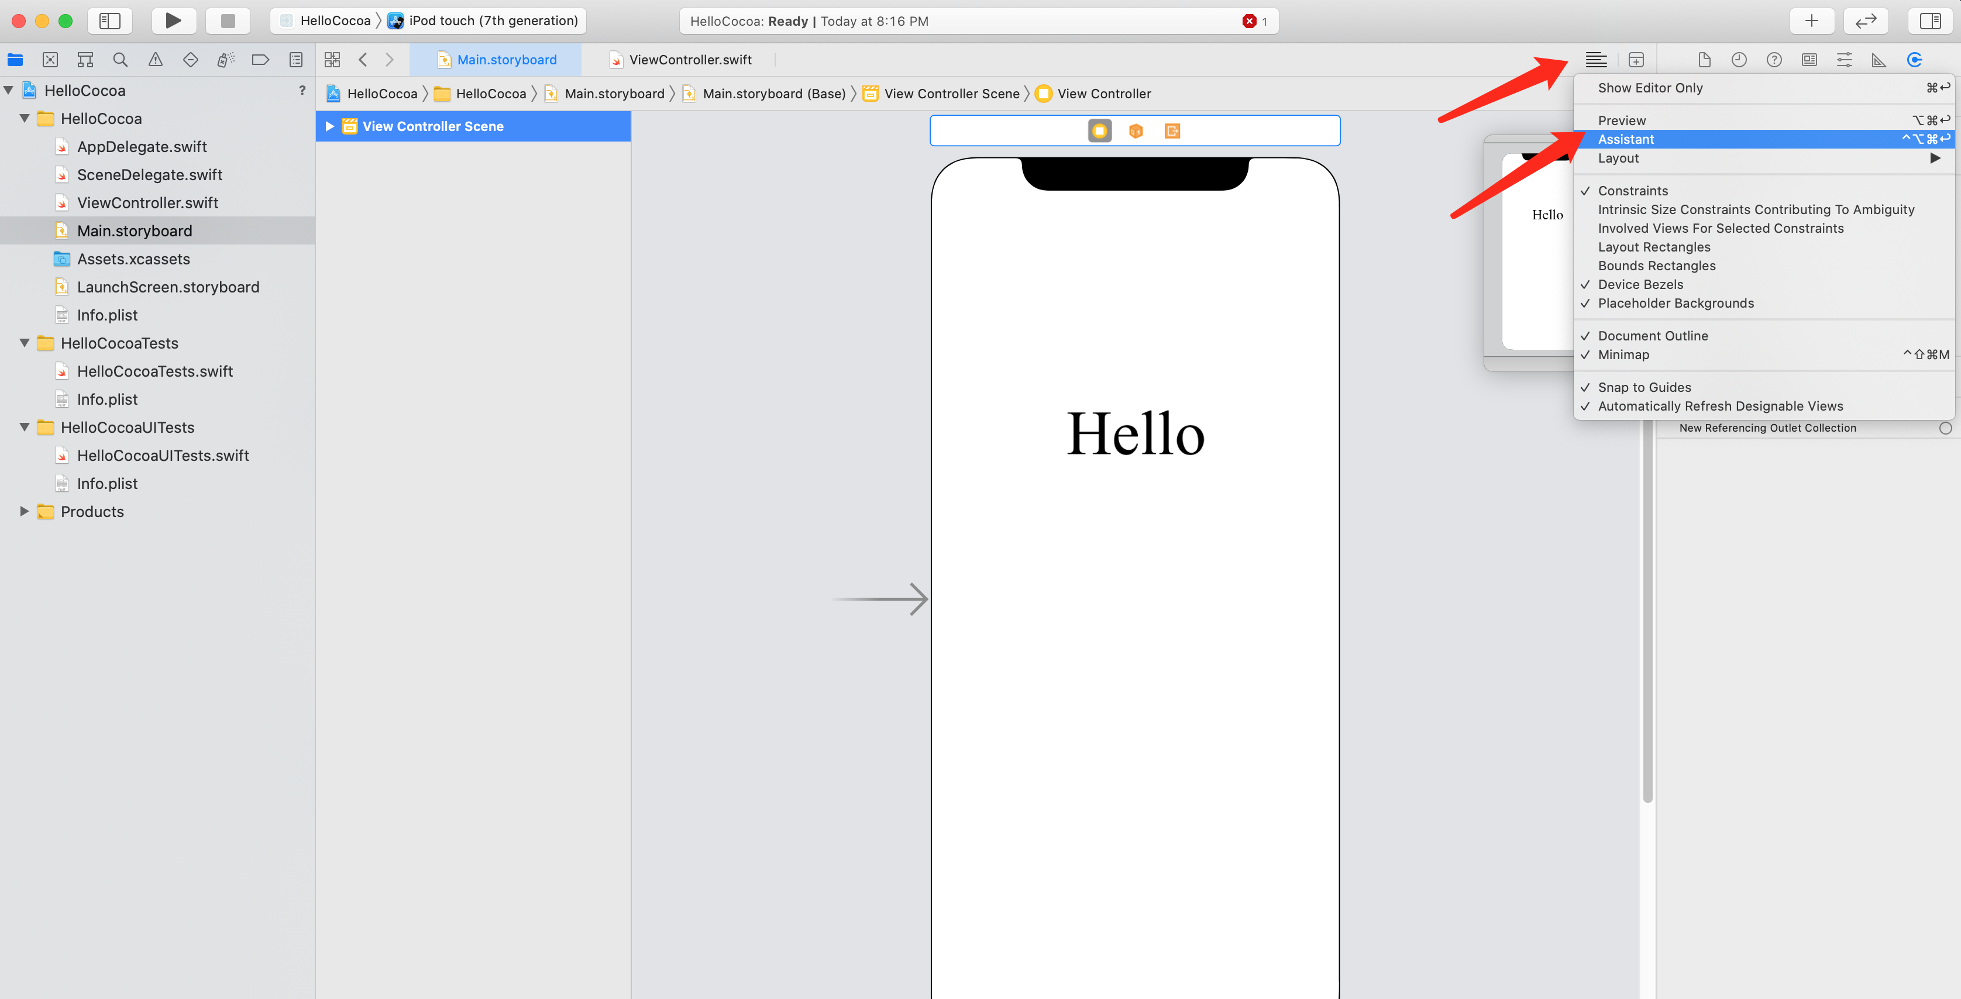

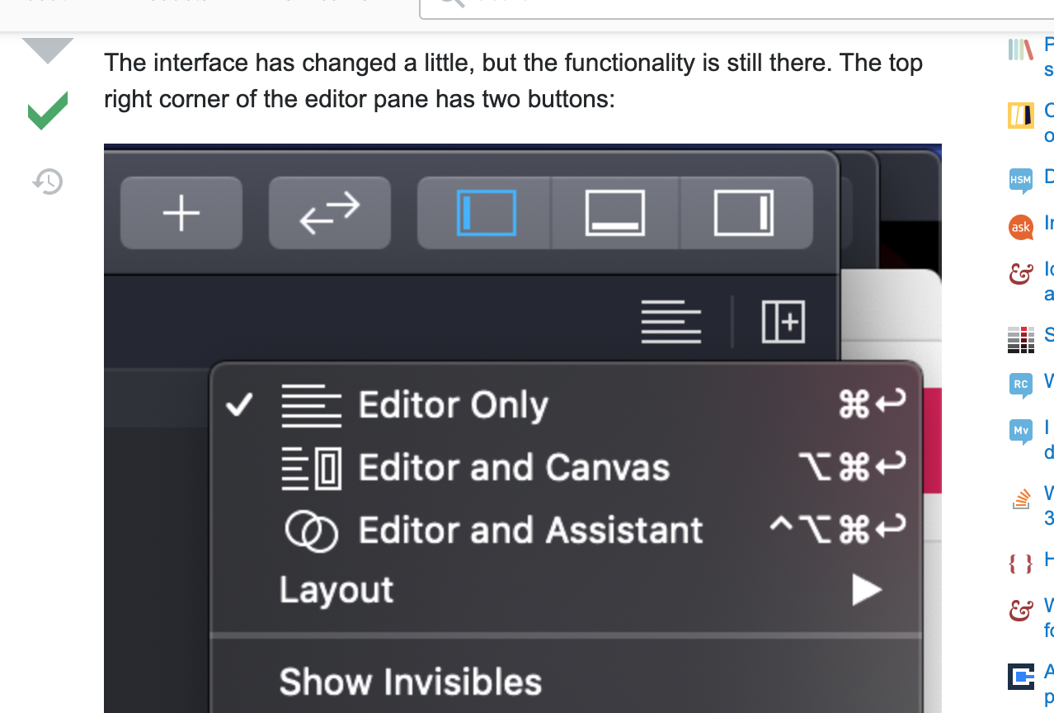

### setTitle("Clicked",for: [])的改变

本来：self.helloButton.setTitle("Clicked", forState: UIControlState.Normal

现在：setTitle("Clicked",for: [])的改变

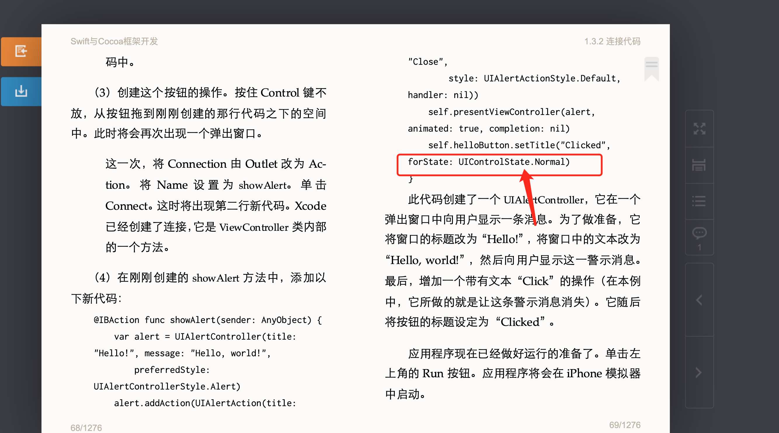

<https://stackoverflow.com/questions/37800342/uicontrolstate-normal-is-unavailable>

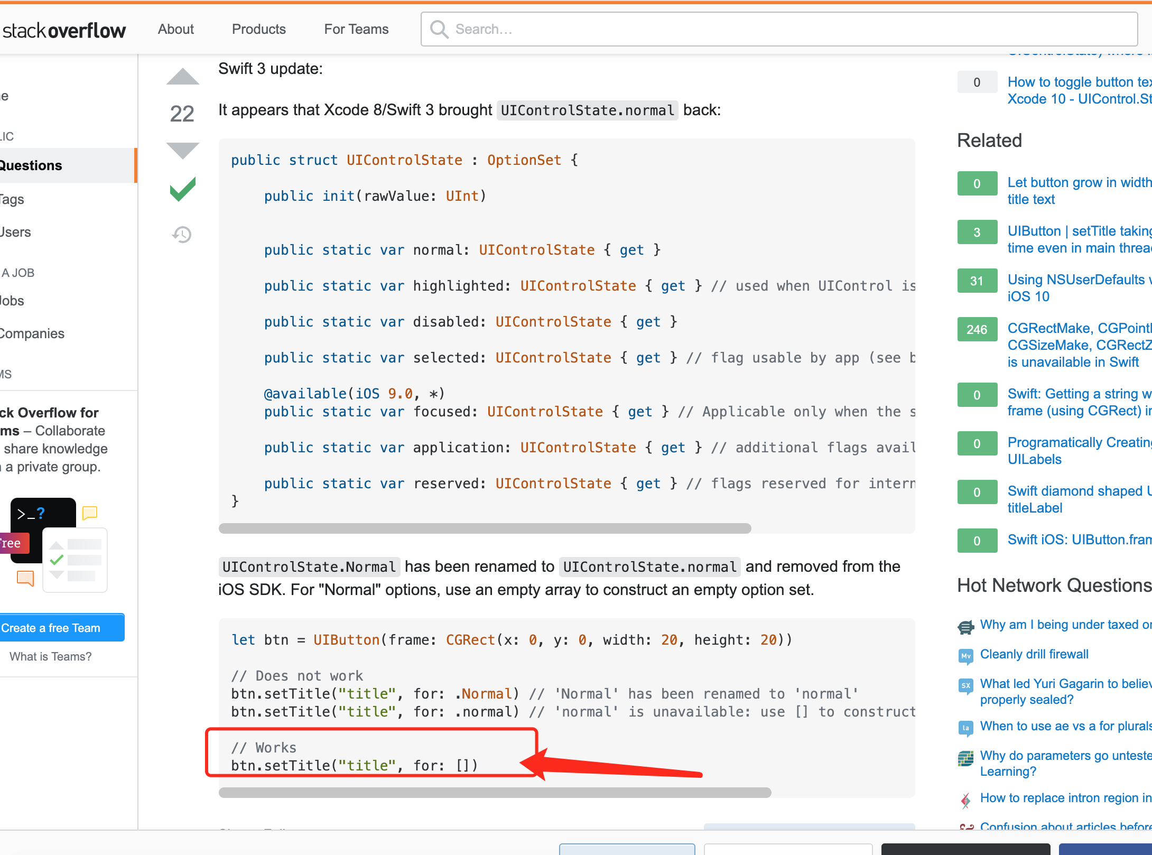

语法大改，变成了这样

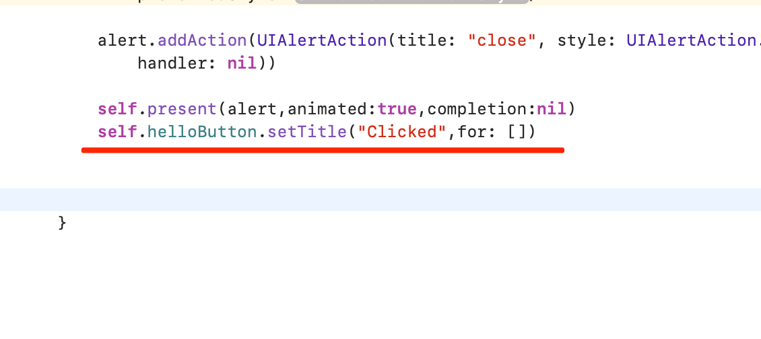

### 一些调试过程

#### Making alert 方法已经改变

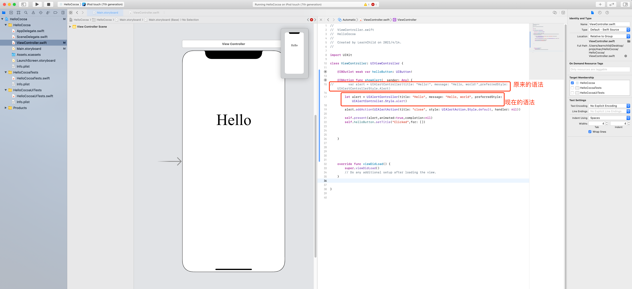

<https://suragch.medium.com/making-an-alert-in-ios-ac36ed5af6d6>

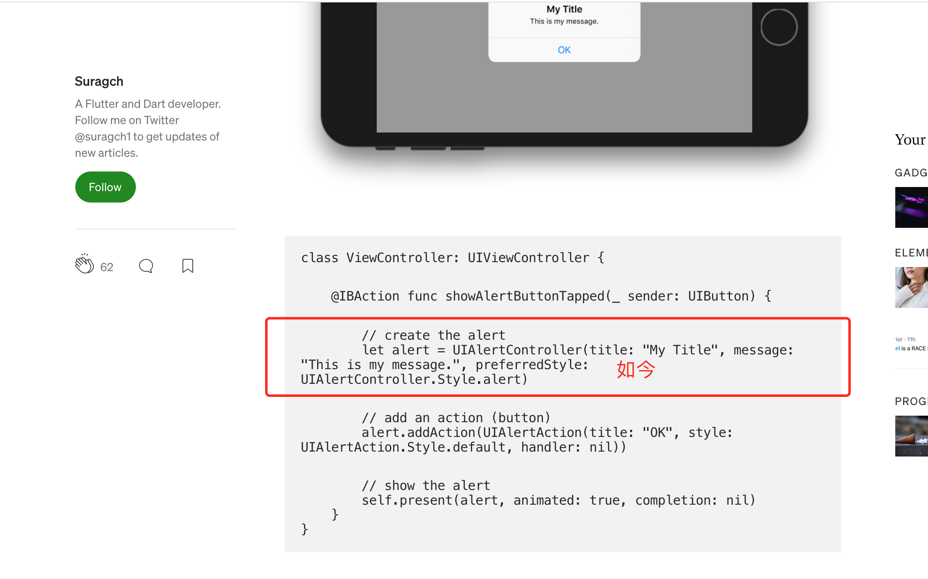

#### Key Commands报错

Key Commands must all have a Title, Key, and Selector. Select each row in the table to check its configuration

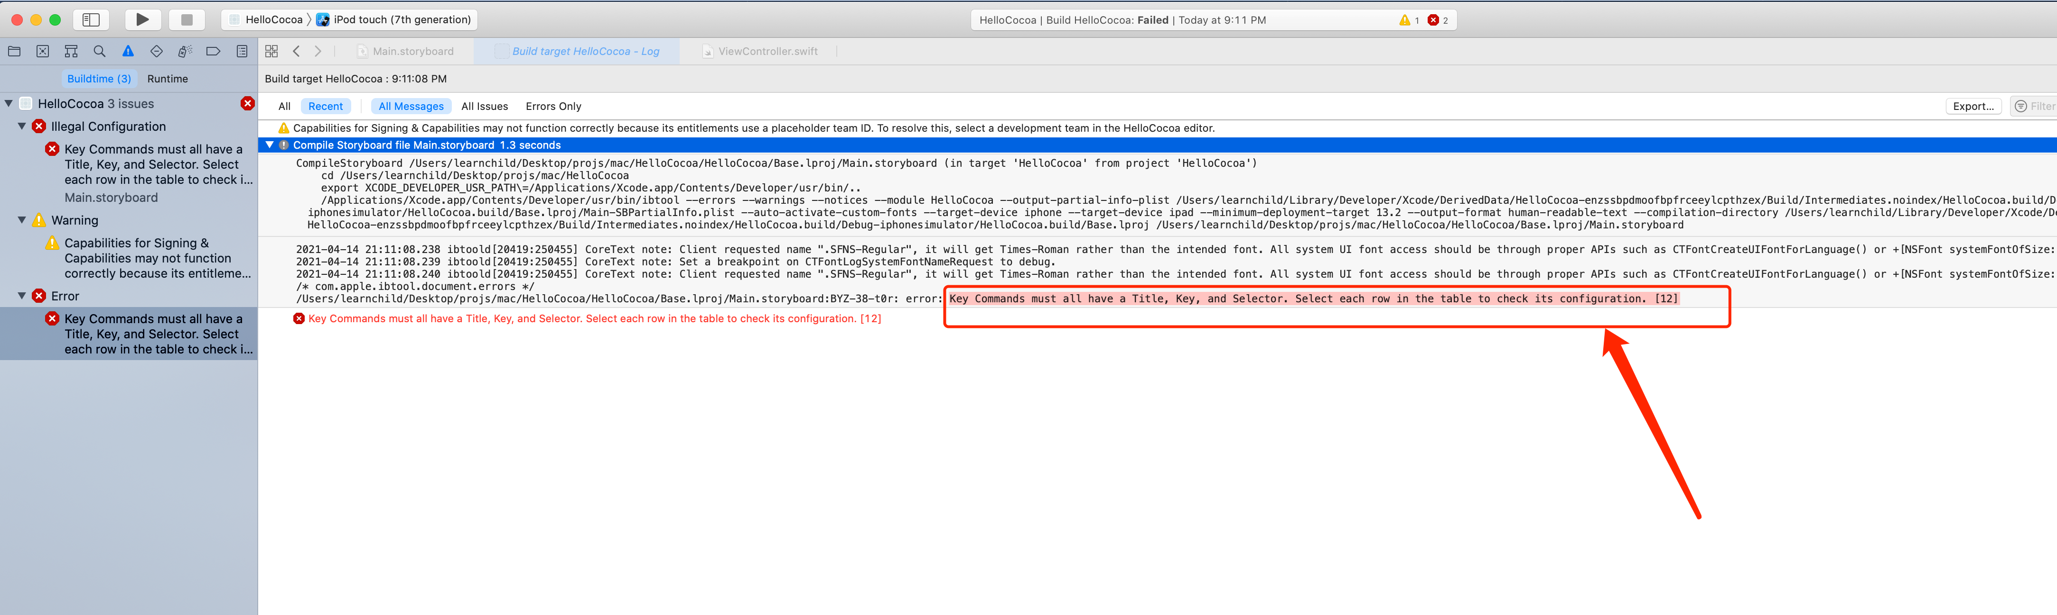

<https://stackoverflow.com/questions/38750691/key-commands-must-all-have-a-title-key-and-selector>

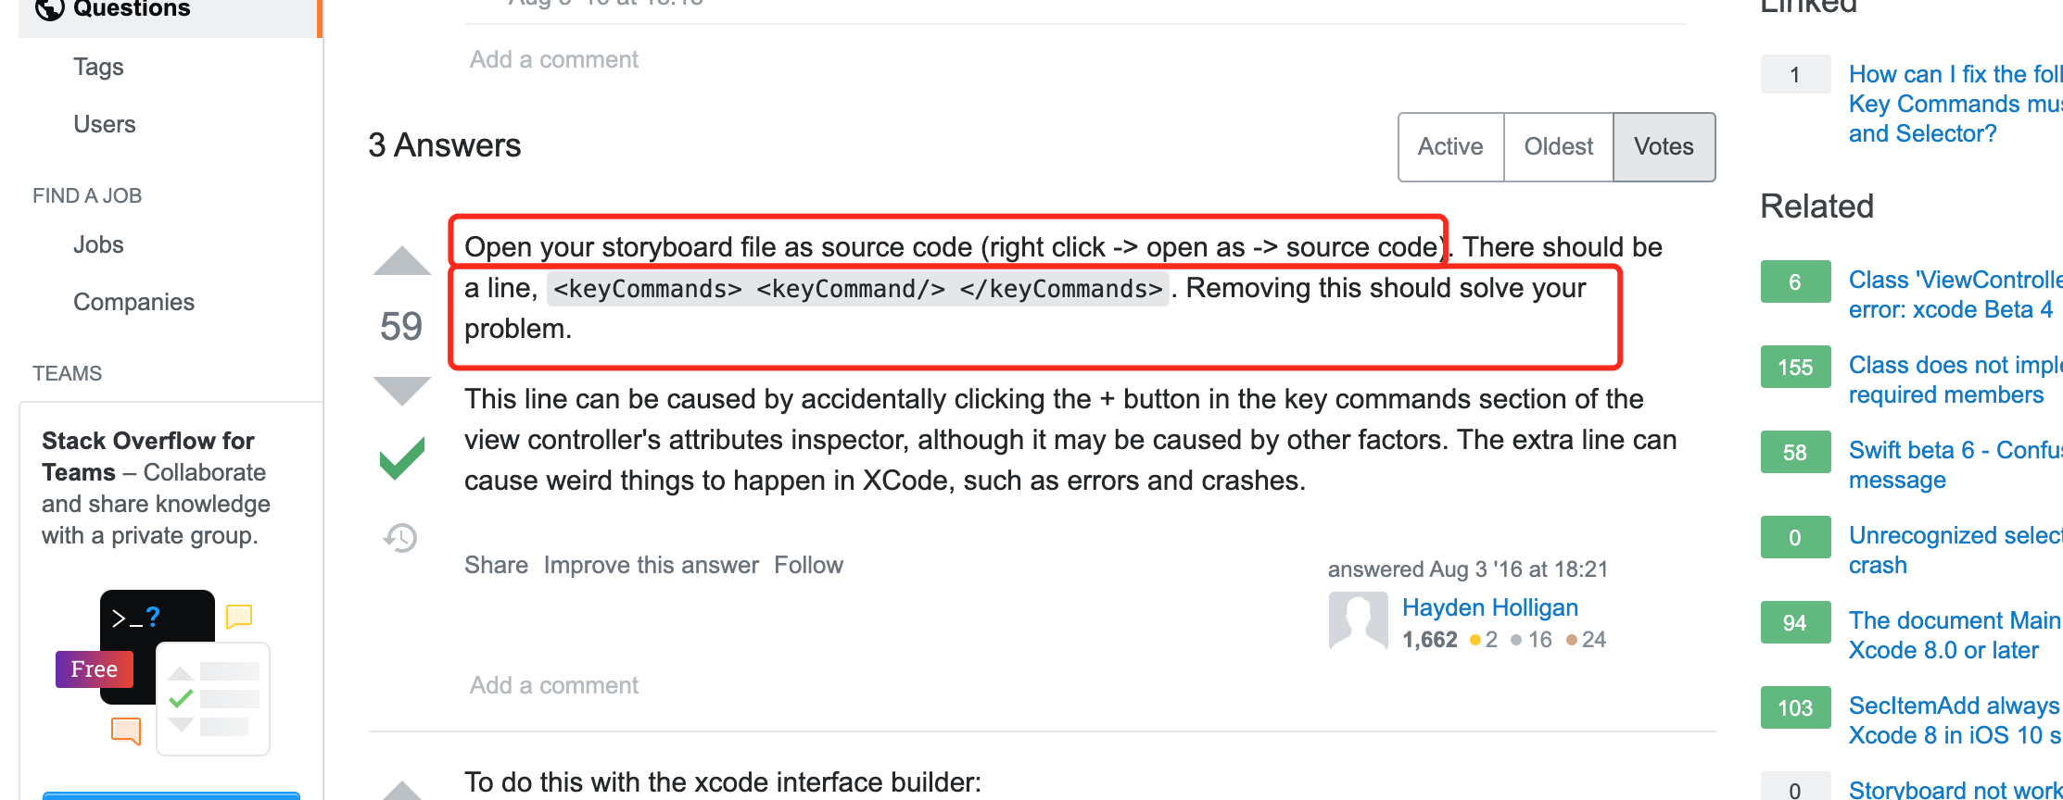

打开故事板源码，

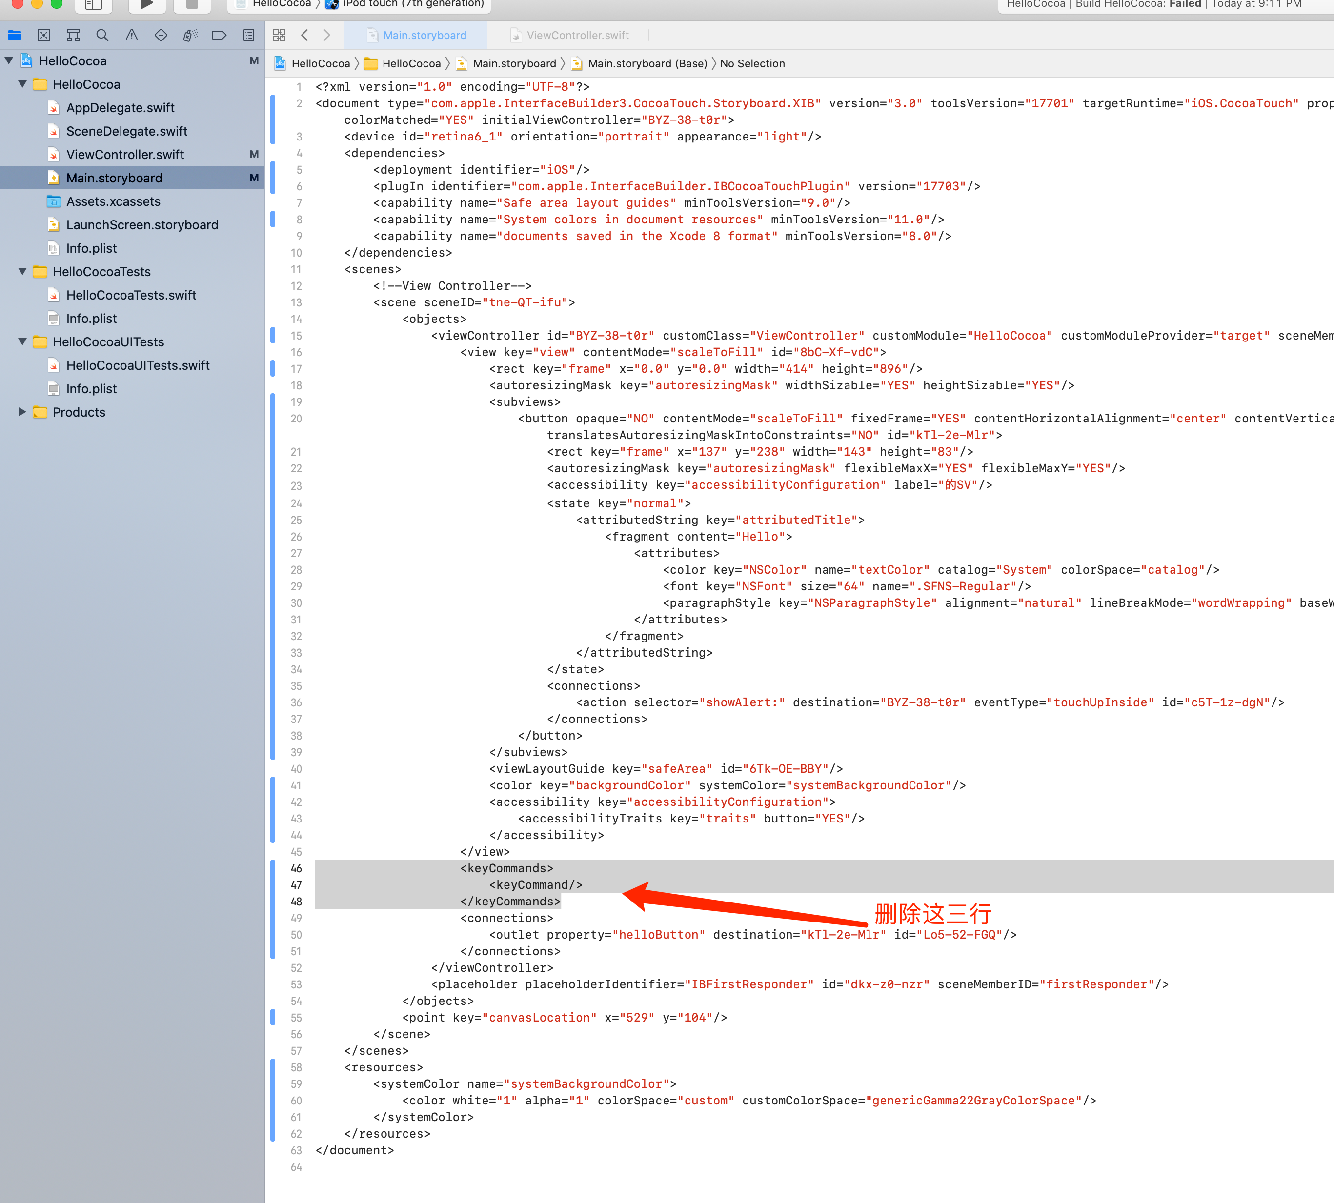

### 成功！

